***FACULTY OF ENGINEERING AND ENVIRONMENT***

|  |  |
| --- | --- |
| **Project Details** | |
| **Module Title:** | MSc Advanced Practice |
| **Module Code:** | KB7056 |
| **Client Name** | AkzoNobel, David Stark |
| **Academic Supervisor** | Dr. Yolanda Sanchez Vicente |
| **Project Title** | Individual report of Paint Testing Drum |
| **Student Name** | Bala Vignesh Subramanian |
| **Student Number** | W19047623 |

Contents

1.Abstract 3

2. Introduction 3

3. Outcome of this project: 4

4. Project Scope 4

5. Analysis of Existing Design 4

6. About existing drum 4

7. Issues in the existing prototype 5

8. Project Plan 5

9. Risk Identification and Mitigation 6

10. Solution 7

11. Analysis of new design 8

11.1 Structural Analysis 9

11.2 Stress Diagram 9

11.3 Strain Diagram 9

12. Calculations 10

12.1 Buoyancy Calculations 10

12.2 Hydrodynamic calculations 10

13. Recommendations 11

14. 3D Printing 12

15. Limitations 12

16. Conclusion 12

References 12

# 1.Abstract

AkzoNobel is the industrial client, the project is based on development of the underwater paint testing drum. As a team to overcome the issues in the existing drum, new thread locking design is proposed, it sounded with good buoyance, ease of loading and unloading with simple assembly properties. Project management practices are undertaken to make this project as a successful one. Meeting with the Academic supervisor, industrial clients paved us to find out the better solution. Indeed, the 3D printing was the main challenging factor we have faced, to sort out the printing issue, the client accepted to take the printing with the help of 3rd party. Finally, we have recommended, another design to make it in a simple manner. Throughout the project, communication was clear between the technical team and academic & industrial supervisor which resulted with achieving client objective.

# 2. Introduction

The aim of this project is to review the underwater paint testing drum design. The industrial client for this project is AkzoNobel, they are the premium providers in the paint industry since 1994. Using the paints in the underwater for aging surface coating is the biggest challenge for the Paint industries. Testing the paints under the water before applying to the ship hull is the mandatory process. Using the paint testing drum, the paints are tested. The project is to investigate and optimisation of existing paint testing drum. The project outlined for 12 weeks, during this period new work culture was explored and project management practices were performed. Gantt chart, risk analysis and communication chart were planned and executed. The new working environment encouraged me to handle the different typical situations and gave a lot of opportunity to learn even during the hard times, which resulted with improvement of interpersonal skills and management skills.

The project is entirely based on the research and development of the existing paint testing drum. As a Project manager I have led this project and guided my teammates throughout the journey. New thread locking system design is implemented to overcome the exiting problems, and the new recommendations are given to make a testing process as a simple one and to improve the buoyancy properties.

The key areas the project which covers are,

* Identifying key challenges in the existing paint testing drum.
* Understanding client’s objectives
* Modelling and simulating new paint testing drum.

Various analysis and key objectives are carried out, and the objectives achieved are.

* Reduced the number of fittings in the existing paint testing drum.
* Ease of sample loading and unloading.
* Avoided the corrosion of Nuts and Bolts.
* Increased Buoyance properties and hydrodynamic properties.

# 3. Outcome of this project:

During this project I have performed in a role of Project manager. The Project plan was used to deliver content and compare actual results to forecasted outcomes. The major outcome as a project manager I have achieved in this project are.

* Understand the needs of the consumer.
* Divide the work down into the team's main objectives and tasks.
* Risks are identified and determined actions are taken.
* Established the milestones and deliverables.

# 4. Project Scope

The project objective is the main part of the project planning that involves the project goals, key deliverables, tasks performed. The project scopes to satisfy the clients objective. The project entitled with the background, identifying the risks, material analysis for underwater testing, works are assigned according to probability of risk level then the project plan is drafted. Key milestones and key deliverables are planned and executed within the planned timeframe.

Figure1 Project Scope

# 5. Analysis of Existing Design

To overcome the existing problems in the existing paint testing drum various brain storming seasons are conducted between the academic supervisor, Industrial client and between the team members, as a result we had overcome the better design to satisfying the clients objective. Once the prototype was received from the industrial client the different analysis was performed in the prototype. The prototype was tested by submerging into the water. Then the portion where it is getting lagged was identified and new design was made according to overcome the issues.

# 6. About existing drum

The existing paint testing drum consists of top and bottom holders, With the use of the bolts both the parts are coupled together. The existing drum can withstand up to 16 strips. Paints are coated in the testing strips and placed in between the top and bottom holders. Once the assembly is completed, the drum will be connected with the shaft and submerged into underwater. The drum will be placed at 15m under the water. With the use of 1.5Hp motor the shaft will get rotated with the speed of 750rpm. The testing will take place for 16 months.

# 7. Issues in the existing prototype

The top and bottom part of the existing prototype was not properly closed. Water will be penetrated into the drum, resulted with corrosion of nuts and bolts. So, the lifetime of the drum will get reduced.

The whole drum assembly was submerged into the underwater, so the bolts will get directly affected by the saline water. Sedimentation of salts above the bolts will start corroding, so the dismantling of drum will be a tricky process

Figure 2,3 Issues in existing design

# 8. Project Plan

The team is grouped with the 4 members, 3 members are from the mechanical background and from the engineering management background. The works are planned accordingly to their academic background. The works started accordingly to probability of risk, key milestones are fixed within the certain timeframe and objectives are achieved. As a project manager, for the 12 weeks the project management plan is planned with the help of communication lead and technical team members.

|  |  |
| --- | --- |
| **Task** | **Key Stakeholder** |
| **Initiation** | |
| Project Kick Off | Project manager |
| Work Allocation | Project manager |
| Report – Gantt chart, Risk assessment | Project manager |
| Communication chart | Communication Lead |
| Academic supervisor meeting | Project Manager |
| Client Kick-Off presentation | Industrial Supervisor |
| **Governance** | |
| Weekly Meeting Timetable | Communication Lead |
| Weekly Reports | Project Manager |
| Key Stakeholder Meeting | Communication/ Project Lead |
| **Technical Information** | |
| Gathering Data | Technical Team |
| Literature survey | Technical Team |
| Designing | Technical Team |
| Analysing Existing Data | Technical Team |
| Technical Report | Technical Team |
| Discussion with clients regarding design | Technical Team |
| Analysing existing design | Technical Team |
| **Documentation** | |
| Mid Term Review | Project Manager |
| Final report and Submission | Team Members |

Table 1 Project plan

# 9. Risk Identification and Mitigation

Identification of risk and working on them is the key factor for the success of this project. By conducting the brain storming seasons with the team members to identify the potential risk and workouts are done to mitigate the risks. After receiving the tasks from the industrial supervisor, the works are divided accordingly to the probability of work.

|  |  |  |  |
| --- | --- | --- | --- |
| **S. No** | **Risk Identification** | **Analyse of Risk** | **Mitigation Measures** |
| **1** | **Interaction and coloration barriers** | Lack of communication between the key stakeholders | Communication chart has been performed and the problems are rectified |
| **2** | **Lack of availability resources about paint test drum on the internet** | It holds the initiation of the project and slows down the interest among the team members | Meeting with an academic supervisor and client meeting helps us to move further with this project |
| **3** | **Existing design** | Lack of availability of resources for paint testing drum design. | Communication with the industrial client to get the 2D drawing. |
| **4** | **Time management** | While initiating the project time plays a major role, due to unavailability of resources project got delayed in achieving key milestones | During an available time, team performed with drafting designs and material selection. |
| **5** | **Lack of Planning** | Due to unaware of drum design, project manager cannot be able to assign the works to team members | Meeting with the client helps to gather an information about the existing paint drum, which helps to plan and work according to an objective |
| **6** | **Team Underperforming** | Improper communication between the team member which leads to underperformance. | Communication chart will help to communicate between the team members that will sort out the problems. |
| **7** | **Impractical proposal** | Unaware of the project description will lead to failure in design and failed to satisfy the clients requirements for a project | A good designer’s risk assessment should identify the hazards and evaluate the risks that may arise from the design, dependent upon the hazard and level of risk the design will satisfy the customers need. |

Table 2 Risk Identification and Mitigation

Stakeholder Communication:

Meeting Outcomes:

|  |  |  |
| --- | --- | --- |
| Meeting with | Purpose | Outcome |
| Academic Supervisor | * New material for underwater testing * Replacement of Nuts and Bolts * Confirmation of new design * Final presentation feedback | * Worked on the feedback and came out with the better solution. * Presentation skills improved. |
| Industrial Client | * Confirmation of new design technology | * Good to understand the underwater working principles. * How to communicate between the industrial persons are learned. |

# 10. Solution

To overcome the difficulties in the existing paint testing drum, Thread locking system was employed. The design was plotted by using the SolidWorks software. By using the same dimensions which is used in the existing drum was used, and new design was plotted. The new method resulted with eradication of buoyancy issues, corrosion of nuts and bolts, increased number of testing strips, reduced number of fittings. Acrylic material was suggested for new design. This material which can be resistant to acids. The material was crystalline in nature and it counteracts the enter of the alkaline.

In this new thread locking design the top holder got threaded with the bottom holder, so the use of nuts and bolts are avoided. Buoyance issues was solved with the increase in weight of the drum. The hollow space was reduced in order to increase the weight. The overtightening was avoided by making an Allen key slot for 7mm in the top holder. The number of testing strips are increased from 16 to 18.

Figure 4 Top part Figure 5 Assembly view

Figure 6 Top part & Bottom part Figure 7 Assembled view

# 11. Analysis of new design

After the design of new design Analysis is performed by using Ansys software. The input for the Analysis is, drum is submerged inside the water for 1m, and motor speed was fixed as 750 rpm. By keeping the drum in the underwater will definitely push back due to the upward gravity, so more stress will be happened in the centre of the drum. Different loads are given at the different portion of the paint testing drum. Structural, stress and strain analysis were analysed for this new drum.

## 11.1 Structural Analysis

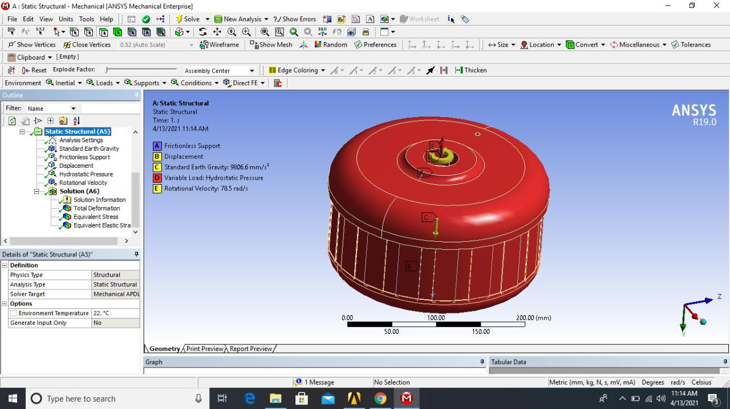

Figure 8 Structural Analysis

The analysis was performed by applying load on the entire drum by giving input load of

Young’s Modulus = 2.5 e^9 Pa, Yield Strength = 2.86 e^7 Pa, Tensile Strength = 6 e^7 Pa

## 11.2 Stress Diagram

Figure 9 Stress Calculation

Stress calculation was made on the centre part of the paint testing drum and by giving different stress values. At finally the drum can tolerate up to Max Stress of 1.802 MPa and Min Stress of 0.0009 MPa.

## 11.3 Strain Diagram

Figure 10 Strain Diagram

The drum can withstand up to Max Strain = 0.033 MPa& Min Strain= 3.447 e^-6 MPa. The diagram which shows the Max strain acts at the centre of the drum which shows in Red in colour. In order to reduce the max strain, the hollow space can be reduced, so it can withstand the more strain.

# 12. Calculations

Buoyancy is the weight of the displaced fluid; A fluid exerts an upward force that resists the weight of a submerged item. It is based on the principle of Archimedes; it can be calculated by using weight of the body and weight if the body immersed in the fluid (Roach, 2011).

## 12.1 Buoyancy Calculations

Mass = 5.55 kg, Volume = 4.6x e^06 mm3, Density = 1025 kg/m3 (sea water), Gravity = 9.81 m/sec2

Flow speed of the water = 1500 m/sec (Apx)

Dynamic Viscosity = 25degree Celsius (0.0089 kg/m2sec)

**Formula, Fb = Vs × D × g Fb = 46.45 N**

**To calculate the weight:**

Formula, Weight = mass x g**, W= 54.38N**

Result: Thread locking design drum resulted with Weight is greater than its buoyancy, so the Drum will get submerged into the body.

## 12.2 Hydrodynamic calculations

In many fluid dynamic conditions, the Reynolds number (Re) aids in the prediction of flow patterns whether it is a laminar or turbulent. For the low Reynolds number, the flow is laminar and for higher Reynolds number the flow is turbulent. So, the Reynolds number is the important characteristics in the Fluid Dynamics (Falkovich, 2018).

**Reynolds Number Calculation:**

* **Rn=(ρVL)/μ** (Dwivedi, 1977)
* Ρ = 1200kg/m3 V = 1500 m/sec L = 0.96 m μ = 8.90 x 10^-4 kg/msec2
* **Rn = 1.942 x 10 ^9**
* **Rn > 4000, so the flow is Turbulent (Sea water flow will be turbulent)**

Comparison of New design and existing design:

|  |  |  |
| --- | --- | --- |
| **Properties** | **Existing Design** | **New Design** |
| Weight | 34.138N | 54.234N |
| Volume | 2.9 x e^6 mm3 | 4.6x e^06 mm3 |
| Buoyancy | 29.15 N | 46.45 N |
| Displacement of Fluid | 2.97 kg | 4.737 Kg |

Table 3 Comparison of new and Existing design

# 13. Recommendations

During the analysis, drum got over strained on centre part, the part will be connected to the shaft. The max strain achieved is 0.033 MPa, after some extend the drum will lose the shape it will got deformed. To avoid the deformation and to give the more loads on the centre of the drum, hollow space should need to reduce to avoid the deformation.

In order to improve the performance of existing paint testing drum by without implementing new design, certain changes are recommended. The existing problems are identified, and necessary steps are taken to mitigate the issues.

Existing design Changes:

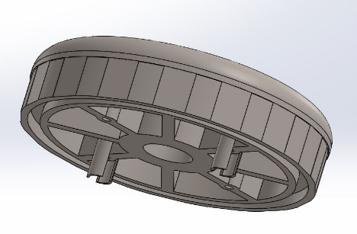 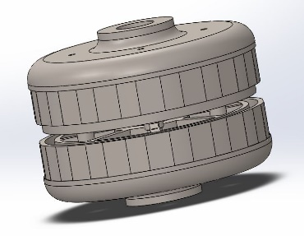

Figure 11 Existing Design Change

In the exiting design there will be gap between the top holder and bottom holder, in order to overcome the issue, extrude cut has been taken in the top part. And the extension in the bottom part, so while coupling it, it will be coupled together, and the penetration of saltwater get avoided.

Plastic Nuts and Bolts:

In order to avoid the corrosion, Plastic nuts and bolts are suggested. Nylon 6.6 with Hex Head, which is resistant to corrosion, oil, and other chemicals.

# 14. 3D Printing

After the design finalised, final presentation with the industrial clients were taken place. After the presentation, the industrial client accepted the design, and he gave the permission to the 3D in university. Due to the uncertainties in the university one of my team member cannot be able to take the 3D printing. Behind the 3D printing, I have taken a personal meeting with industrial client to confirm the design finally design was accepted. And the client he confirmed that with the help of the3rd party he will do the printing.

# 15. Limitations

In the new Thread locking system, Acrylic is the material used for the replacement. For 3D printing bed should kept at 120degree Celsius, for the manufacturing. But for Acrylic material max withstand temperature is 80degree Celsius. So, bed should need to maintain with in 80 degree, to avoid the deformation.

Drum will be fully packed in this new design, so in order to increase the buoyancy property the hollow space should need to reduce. Simultaneously the weight of the object will increase. The motor HP is 1.5 so the shaft will start vibrating.

# 16. Conclusion

The project tends to satisfy the clients objective, new design thread locking system overcomes the flaws in the existing design. The findings of experiments to identify the ideal circumstances for application are summarised in the directions of usage, which are offered to the client to ensure that they get the best results in testing the paint. Stage by stage process work has done, starting from the initiation, understanding the clients brief, identifying risks, assigning the work, meeting with the stakeholders were undertaken and these are the key performances of this project. The main objective of this project is to achieve the better buoyancy than the existing design, so the different methods are tried, and we came out with the new design to satisfy the all the clients objective. This project projected the new vision, how to work in the real industry which helps to learn and develop the interpersonal and communication skills.

(Total Word Count: 2690)

# References

Dwivedi, P. N., 1977. "Particle-fluid mass transfer in fixed and fluidized beds".. *Industrial & Engineering Chemistry Process Design and Development.,* 16(2)(doi:10.1021/i260062a001), pp. 157-165.

Falkovich, G., 2018. *Fluid Mechanics.* ISBN 978-1-107-12956-6. ed. s.l.:Cambridge University Press..

Roach, P., 2011. *Cambridge English Pronouncing Dictionary.* ISBN 9780521152532 ed. Cambridge: Cambridge University Press.